- Download XAMPP (Project use PHP v8)

Link download: <https://www.apachefriends.org/download.html>

- Download and install Composer (latest version)

Link download: <https://getcomposer.org/download/>

**\* Lưu ý cài đặt XAMPP trước Composer để tránh xảy ra lỗi**

- After downloading the .rar project file, proceed to extract it in Disk(C,D,..):\xampp\htdocs

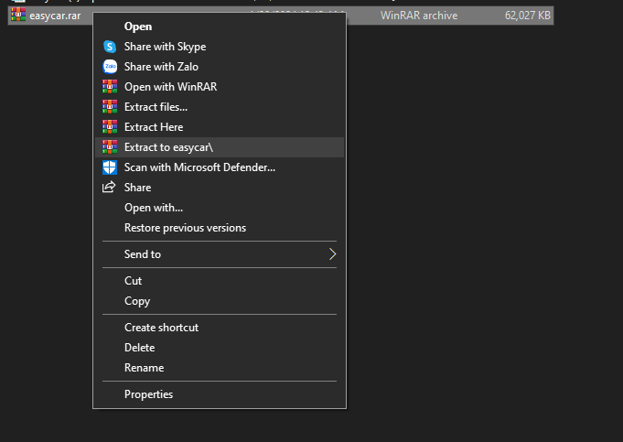

- Override Ctrl + Right click on the extracted project folder and select "Open Git Bash Here"

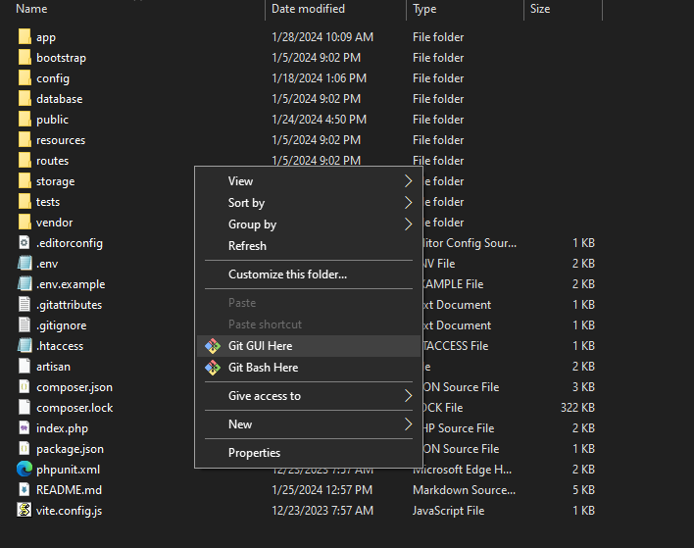

- In the Git Bash window, type the following commands one by one

1. **“composer update”**



2. **”composer dumpautoload”**



- The project uses phpmySQL server, so it needs a server containing a database named "easycar" for you to test run the project.

Here I use XAMPP to create a local server (you can use other software)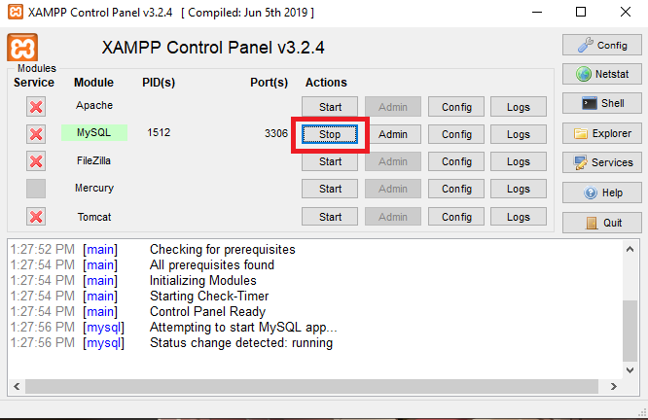

- Proceed to create a database named “easycar” on your local phpmysql server. Here I use the DBever interface to create the database (you can use other software)

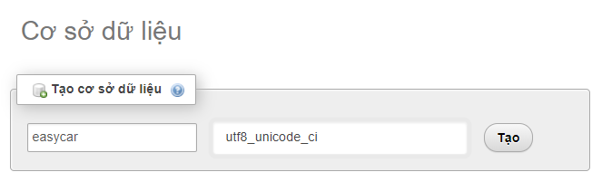

Import data from file easycar.sql to “easycar” database

1. **“set in config select database.php”**

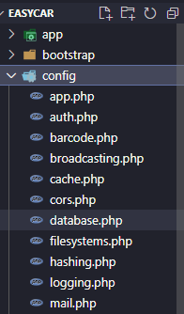

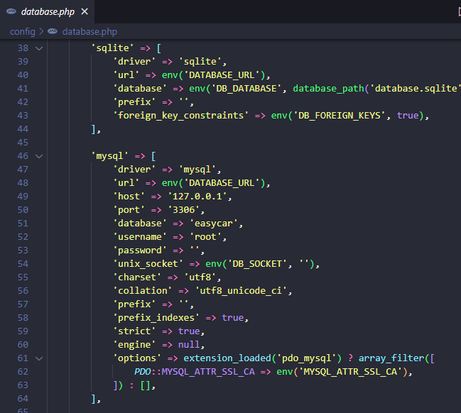

Then go to the browser and click: localhost/easycar/ (localhost:: depends on xampp port, recommend use port 83 to test payment)

- Image of successful project test run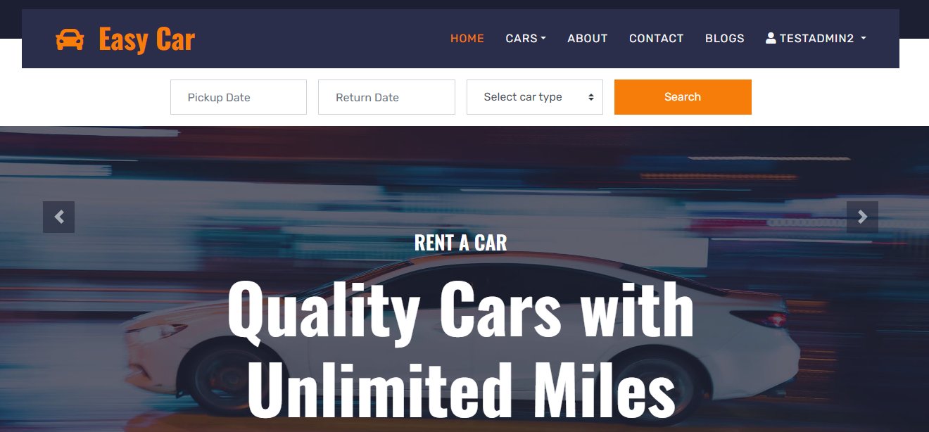

* Additional

Login account, use one of the following accounts:

|  |  |
| --- | --- |
| **Username** | **Password** |
| admin01@gmail.com(admin) | 12345678 |
| moderator01@gmail.com(moderator) | 12345678 |
| user01@gmail.com(user) | 12345678 |

Check payment Info VNPAY:

|  |  |
| --- | --- |
| **Ngân hàng** | NCB |
| **Số thẻ** | 9704198526191432198 |
| **Tên chủ thẻ** | NGUYEN VAN A |
| **Ngày phát hành** | 07/15 |
| **OPT** | 123456 |

(Lưu ý sau khi thanh toán, VNPAY sẽ trả về địa chỉ localhost:83, các máy đang chạy trên cổng localhost khác có thể sẽ gặp lỗi)